Haneen Mohamed

Task 3

2-4

**Step 1:**

My design has background similar to white and the navbar have like home page, products, contact page and sign up button.

Home page have image, heading and paragraph about the site.

In the end of home page, I put sign up form to make user to sign up.

**Step 2:**

I ask some people for there opinion on my design to make some editing, and they tell me to change the background color and put the sign-up form to the end of the home page to make it easy for user to sign up in the website.

In the products page they tell me to divide the page into to parts one part to the image of the products and the second part to explain the products and the price of products and put button for buy the products. The contact us page they tell me to put for to make users to contact with the support team easily.

**Step 3:**

When I asked my classmates, they tell me to change the background color from white to black and I change it into black.

They tall me that the design of the logo is not good, I change the logo design I make the text of the logo white.

There opinion is to change the color of the button and make the radius high, I increase the radius of buttons and make their color green.

They tell me that I have to change the image of the home page, I change that with high quality image.

They tell to put form to make it easy to user to sign up in the website, I make form have the email input, password input and Repeat Password to make sure they enter the correct password.

In the products page they tell me to make the image of the products big, I make the products images bigger than the oldest style and I divided the page to two parts and make half for the image of products and the other half to explain the product and I put button to make it easy to the user to buy the products.

Contact us page their opinion to put form to make it easy to contact with support team, I put this form and I put into these form name input, input to enter the subject, input to enter the comment, input to enter the email and input to enter the phone to contact with theme when the support team respond to there question.

**Step 4:**

* I will change the nav bar color and the logo of the design.
* I will change the background color of pages.
* I put the form for the sign up to make it easy to users to sign in to the web site.
* I put form in contact us page to make it easy for user to ask the support team and contact with them.
* I will change the buttons color to make it suitable with the back ground color.
* I changed the image in the home page.

**Step 5:**

I changed the first design because I found the second design suitable and was chosen by many who took their opinion on the design.

**The first design:**

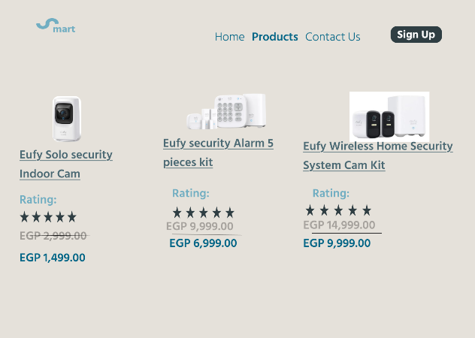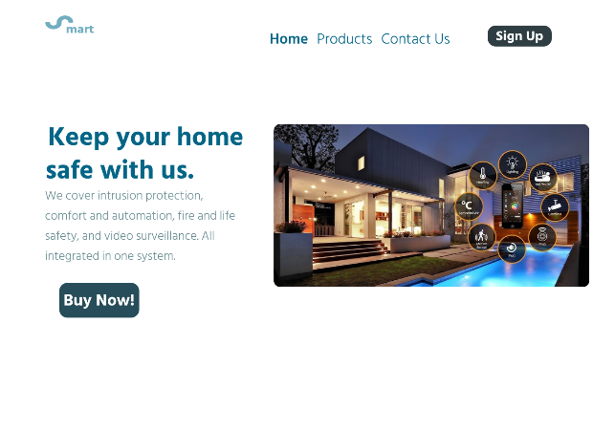

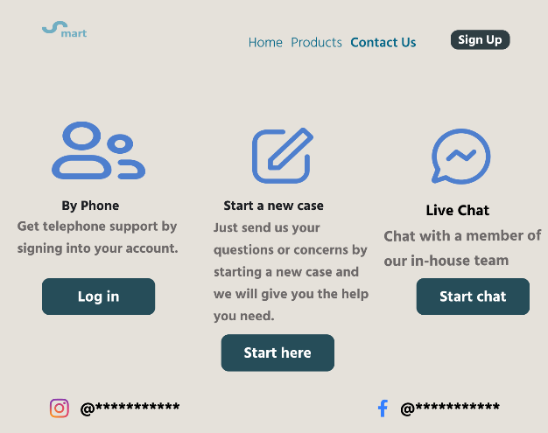

**The second design:**

